

CONFIGURATON MANAGEMENT PLAN

**Version 1.0**

**Qui Ngo**

**05/05/2017**

**Revision History**

|  |  |  |  |
| --- | --- | --- | --- |
| **Version** | **Date** | **Author** | **Content** |
| 1.0 | 05/05/2017 | Qui Ngo | Release Configuration Management Plan Version 1.0 |
| 1.1 | 17/05/2017 | Qui Ngo | Update :   * 3.1 Process Diagram * 3.2 Description |

Table of Contents

**1.** **Document Introduction.** 3

**1.1.** **Purpose** 3

**1.2.** **Audience** 3

**2.** **Configuration Management** 3

**2.1.** **Organization** 3

**2.2.** **Tools, environment and infrastructure** 4

**3.** **Configuration Management Process** 4

**3.2 Description** 4

**4.** **Detail Configuration Plan.** 5

**4.1.** **Configuration Items** 5

**4.2.** **Configuration Identification** 5

**4.2.1.** **Document name** 5

**4.2.2.** **Document content** 6

**4.2.3.** **Symbols for drawing process** 7

**4.2.4.** **Process Submit document on repository** 8

**4.2.5.** **Process make change document on SVN** 9

**4.2.6.** **Tool for access to repository** 10

**4.2.6.1 Document and Source code repository** 10

**4.2.7.** **Tools for editing documents** 11

**4.2.8.** **Organize folders to store document** 11

**5.** **Configuration Auditing/Reporting** 12

**6.** **Reference** 12

**List of Table**

**Table 1. Audience Member 3**

**Table 2.Tools, Environment And Infrastructure 4**

**Table 3. Description For Cm Process 6**

**Table 4. Configuration Items 6**

**Table 5. Document Name Code 6**

**Table 6.Described For Word Documents 8**

**Table 7.Described For Excel Documents 8**

**Table 8.Tool For Access To Repository 10**

**Table 9.Document And Source Code Repository 11**

**Table 10.Tools For Editing Documents 11**

**List of Figure**

**Figure 1.Configuration Management Process 5**

**Figure 2. Symbols For Drawing Process 8**

**Figure 3.Process Submit Document 9**

**Figure 4.Process Make Change Document 10**

**Figure 5.Folder For General 11**

**Figure 6.Folder For Private 11**

**Figure 7. Folder For Meeting Minute And Template 12**

**Figure 8. History On Svn 12**

1. **Document Introduction.**
   1. **Purpose**

The document is intended to serve as a standard for team members in the execution of the change management process. It outlines the objectives of the Configuration Management Plan, details what products are to be placed under change control, and describes the processes by which work products are controlled.

* 1. **Audience**

|  |  |  |
| --- | --- | --- |
| **Intended Audience** | **Name** | **Reading Suggestions** |
| TripleX team Member | * Tan Huynh * Qui Ngo * Van Phan * Nhuan Tran * Thang Nguyen | Detailed communication plan report |
| Mentor | * Nam Vu | Detailed communication plan report |
| Project Manager | * Van Phan | Detailed communication plan report |

TABLE 1. AUDIENCE MEMBER

1. **Configuration Management**
   1. **Organization**

The ECB configuration management will be involved in configuration management activities.

Responsibility of configuration management: Because when develop team project we need follow regulations to support management better. All document in process need synchronize for Configuration Management Plan.

General guideline:

* + - * When you creating documents or making changes, you need follow these general guidelines to prevent collisions.
      * If you not sure about the name of a new file or new directory where it should be saved, you need asked configuration manager in the team.
      * If you create a new file, check in this document if there is a convention that applies.
      * Not all artifacts produced during the software development project should be under configuration management. Files created as an intermediate step to the creation of an artifact should not be copied into the depot, even if these files are shared among team members. If we put under configuration management every file we create, the depot we’ll get cluttered. Use your best judgment here.
      * Many artifacts will be Word documents such as this plan. They all should use the same visual style and basic structure. Use the template available and avoid formatting paragraphs—use the styles available in the template.
      * Some artifacts will be PowerPoint presentations. For any studio-related presentation, use the PowerPoint template available.
  1. **Tools, environment and infrastructure**

|  |  |
| --- | --- |
| **Tool** | **Description** |
| Microsoft Office 2013 | Team uses this tool to develop document, text editor. |
| Microsoft Project 2013 | Team uses this tool to develop schedule. |
| Microsoft Visio 2013 | This tool is used for develop processes. |
| Xampp | This tool is used for develop server |
| Sublime Text 2 or 3 | This tool is used for develop Website |
| Android Studio | This tool is used for develop Mobile App |
| MySQL | Team uses this tool to develop database |
| GitHub | Team uses this tool to storage document |
| SourceForge | This tool is used for store source code. |

TABLE 2.TOOLS, ENVIRONMENT AND INFRASTRUCTURE

1. **Assign Task Management Process**

**3.1 Process Diagram** 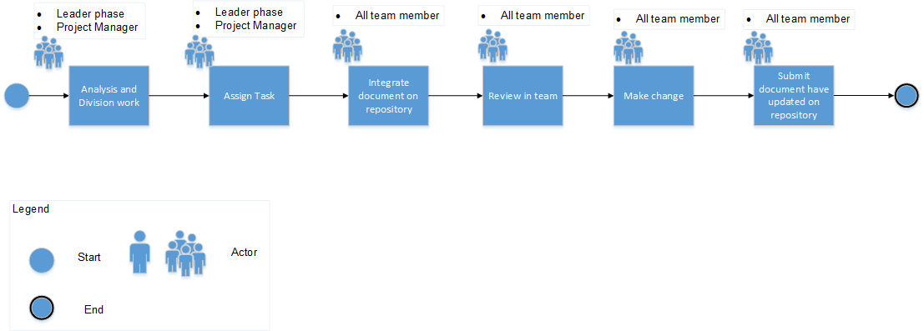

FIGURE 1.ASSIGN TASK MANAGEMENT PROCESS

**3.2 Description**

|  |  |  |  |
| --- | --- | --- | --- |
| **No** | **Activity** | **Description** | **Role** |
| 1 | Analysis and Division work | Project Manager and leader each of phase before assign task for member in team will meeting to analysis and division work for member sure just only one member can execution work that task  Note : No two member in team work one task | Project Manager  Leader Phase |
| 2 | Assign task | After Analysis and division work step, PM and Leader phase assign task for each of member in team | Project Manager  Leader Phase |
| 3 | Integrate document on repository | When member in team execution and have done work will submit document in general repository that is Github | All team member |
| 4 | Review in team | After integrate document, PM will review all document of member, another member comment give for comment, feedback. | All team member |
| 5 | Make change | After Review in team step, each of member will make change themselve document | All team member |
| 6 | Submit document have changed in repository | Finally, each of member in team will submit again document have changed from last step and change version for document. PM will get version final of document | All team member |

TABLE 3. DESCRIPTION FOR CM PROCESS

1. **Detail Configuration Plan.**
   1. **Configuration Items**

|  |  |  |  |
| --- | --- | --- | --- |
| **No.** | **Category** | **CIs** | **Item List** |
| **1** | Document | Requirement | Name rule, font, size, color,content.  Revision.  In progress version (Ex: ver1.1, ver1.2 …)  Base line version (Ex:ver1.0,2.0,3.0…). |
| Architecture and Design |
| Implementation |
| Testing |
| Project Management |
| **2** | Drawing | Use case | Symbols for drawing |
| Class Diagram |
| Sequence Diagram |
| Context Diagram |
| **3** | Tool | Develop | Subline text, Xampp,Android Studio |
| Draw | Microsoft Visio |
| Create Document | Microsoft Word, Excel |
| Management | Microsoft Project, Mindjet, Excel |

TABLE 4. CONFIGURATION ITEMS

* 1. **Configuration Identification**
     1. **Document name**

|  |  |  |
| --- | --- | --- |
| **No.** | **Process Name** | **Process code** |
| 1 | Project Management | PL |
| 2 | Requirement | RE |
| 3 | Architecture | AR |
| 4 | Detail Design | DD |
| 5 | Implementation | IM |
| 6 | Testing | TE |

TABLE 5. DOCUMENT NAME CODE

***<Name of document> = <Acronym of project>_<Code>_<Name>_<X.X>***

* ***“Acronym of project”*** is name of project
* ***“Code”*** is name code of document
* ***“Name***” is the name of document
* ***“X.X”*** is version of documentation: v0.1, v0.2…

Ex: Name of configuration management plan document of ECB project:

**ECB_PM_ConfigurationManagerment_Ver1.0**

Note: Name rules for the meeting minute and time log:

* Meeting minute with customer:

**ECB_MeetingMinutes_Customer**

* Meeting with mentor:

**ECB_MeetingMinutes_Mentor**

* Meeting with team:

**ECB_MeetingMinutes_Team**

Time log:

**ECB_Timelog_<FirstName><LastName>**

* + 1. **Document content**
       1. **Described for Word documents**

|  |  |
| --- | --- |
| **Component** | **Regulations** |
| Font | Arial/Arial(Body) |
| Type | * Title: * Size 28 * Font: Arial/Arial(Body) * Font style: Bold * Font color: White * Header level 1: * Size 14 * Font: Arial/Arial(Body) * Font style: Bold * Font color: Red * Header level 2: * Size 12 * Font: Arial/Arial(Body) * Font style: Bold * Font color: Red * Header level 3: * Size 12 * Font: Arial/Arial(Body) * Font style: Bold * Font color: Red * Header level 4: * Size 12 * Font: Arial/Arial(Body) * Font style: Bold * Font color: Red |
| Table | * Column Header: * Fill color: Dark Red * Size: 12 * Font color: White * Font style: Bold * Position: Align Left * Cell: * Fill color: No color * Size: 12 * Font color: Black |
| Header | * As header of this document |
| Footer | * As footer of this document |

TABLE 6.DESCRIBED FOR WORD DOCUMENTS

* + - 1. **Described for Excel documents**

|  |  |
| --- | --- |
| **Component** | **Regulations** |
| Font | * Arial |
| Column header | * Fill color (background): Dark Red * Size: 12 * Font color: White * Position: Align Left |
| Cell | * Fill color (background): No Fill * Size: 12 * Font color: Black |

TABLE 7.DESCRIBED FOR EXCEL DOCUMENTS

* + 1. **Symbols for drawing process**

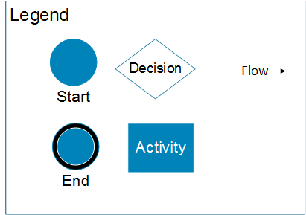

FIGURE 2. SYMBOLS FOR DRAWING PROCESS

* + 1. **Process Submit document on repository**

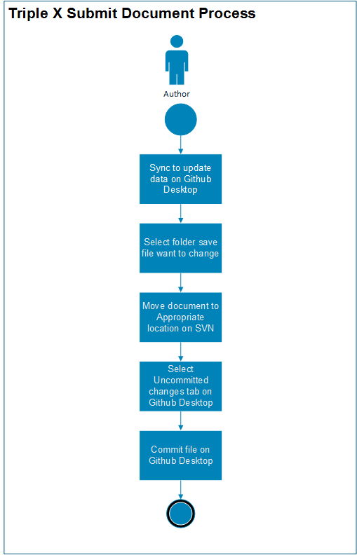

FIGURE 3.PROCESS SUBMIT DOCUMENT

* + 1. **Process make change document on SVN**

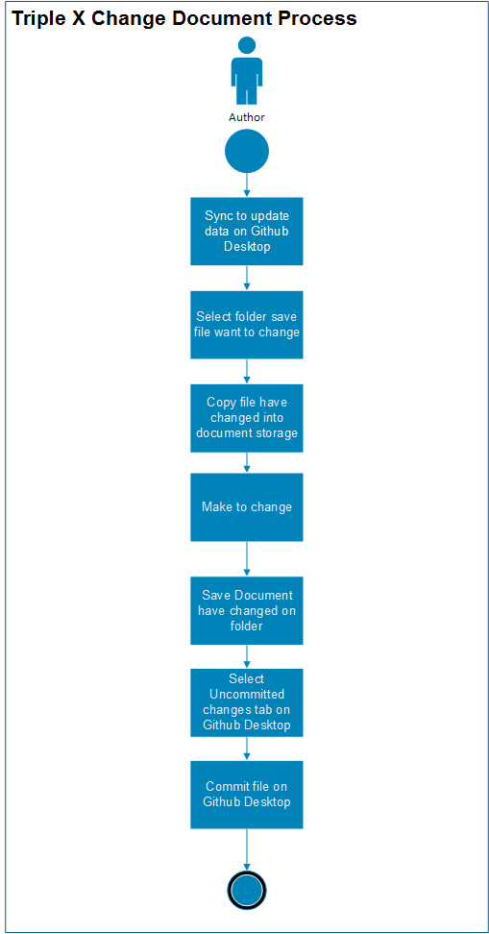

FIGURE 4.PROCESS MAKE CHANGE DOCUMENT

* + 1. **Tool for access to repository**

|  |  |
| --- | --- |
| Criteria | Description |
| GitHub SVN | When member commit or update document to repository, they will use SVN Github. |
| Source Force sever | Place data will access |

TABLE 8.TOOL FOR ACCESS TO REPOSITORY

### **4.2.6.1 Document and Source code repository**

|  |  |
| --- | --- |
| **Criteria** | **Description** |
| Name | GithubSVN-Ver-3.3.4 |
| URL | <https://github.com/vanphan1307/TripleX/> |
| Username | Van Phan  Nhuan Tran  Qui Ngo  Thang Nguyen  Tan Huynh |
| Password | Use password of account member |

TABLE 9.DOCUMENT AND SOURCE CODE REPOSITORY

* + 1. **Tools for editing documents**

|  |  |
| --- | --- |
| Name | Description |
| Microsoft office 2013- 2016 | Use to create/ edit document |
| Microsoft Visio 2013- 2016 | Use to create/ edit document |
| Microsoft Project 2013- 2016 | Use to create/ edit document |

TABLE 10.TOOLS FOR EDITING DOCUMENTS

* + 1. **Organize folders to store document**
* 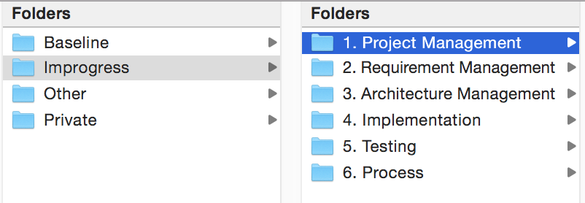**Folder for General**

FIGURE 5.FOLDER FOR GENERAL

* **Folder for Private**

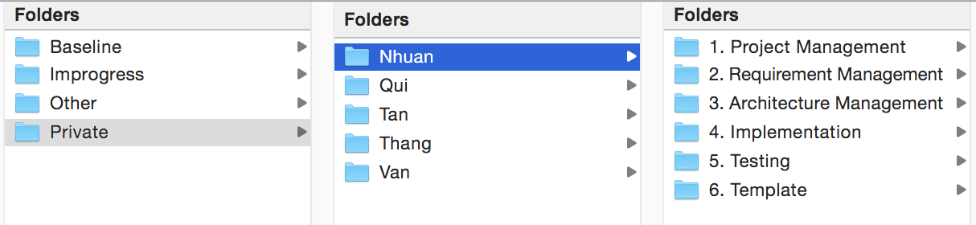

FIGURE 6.FOLDER FOR PRIVATE

* 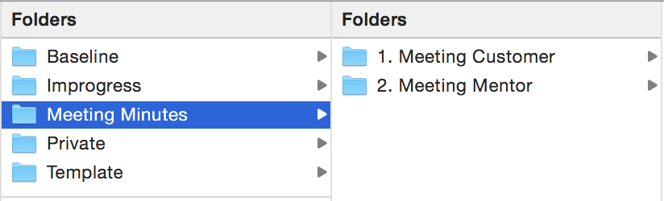**Folder for Meeting minutes and template**

FIGURE 7. FOLDER FOR MEETING MINUTE AND TEMPLATE

1. **Configuration Auditing/Reporting**

If user wants to track, measure or view report in SVN server, user chooses Show log feature:

* 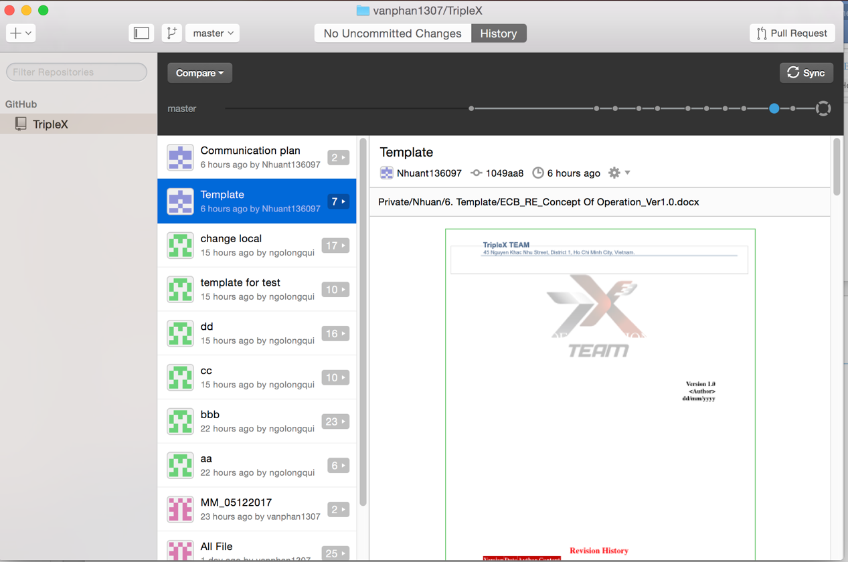For viewing who submit or modify document on SVN follow History

FIGURE 8. HISTORY ON SVN

1. **Reference**

Capstone K18 1st and 2nd